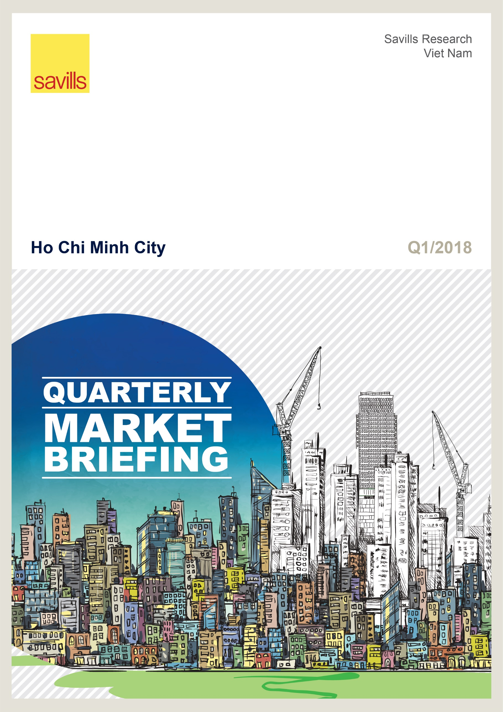

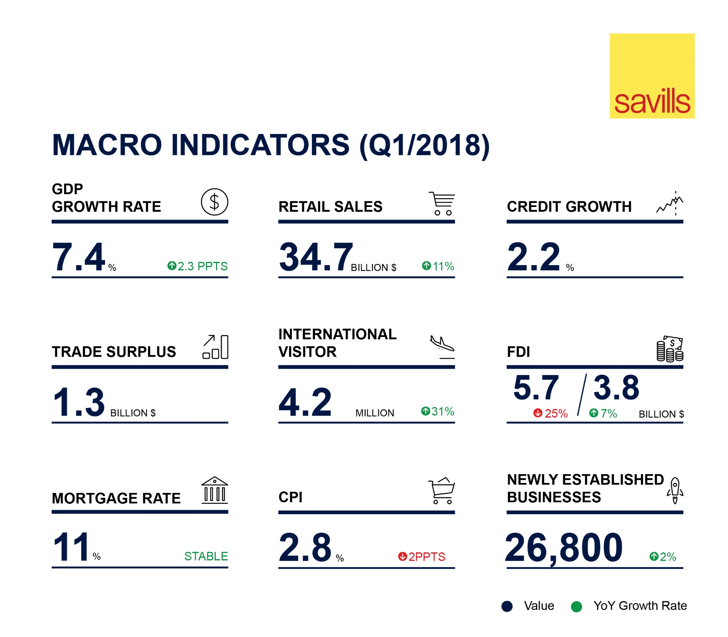
GDP growth achieved 7.4% in Q1/2018, the highest in Q1 for the last 10 years. The main driver was the industry and construction sector, followed by services. Inflation was well-controlled with CPI increasing by 2.8% year on year (YoY).
Strong export value of US$54billion resulted in a trade surplus of US$1.3 billion. The EU is the largest export market, followed by the USA.
International visitors continued to trend up with 4.2 million arrivals, up 31% YoY.
Total registered FDI was US$5.7billion, with Korea as the largest contributor. Disbursed FDI reached US$3.8billion, up 7% YoY.

RETAIL: SOFT PERFORMANCE IN NON-CBD
Total stock was over 1.2 million m² with 73,000 m² added from the entry of three new supermarkets and two shopping centers. Three closures and three changed uses withdrew 39,200 m².  Average gross rent decreased slightly -1% quarter-on-quarter (QoQ). Average occupancy had a slight decrease of -1ppts due to new supply in non-CBD with low rent and occupancy. New fashion brands and international F&B entries replaced unappealing tenants.  Sales focused on F&B, clothes and household appliances. Automated convenience and click-to-brick become popular. E-commerce continuously attracted investment, with Amazons entry announcement a highlight. |  | FIGURE 1  Source: Savills Research & Consultancy
office: STRONG PERFORMANCE
Four new projects including one Grade B and three Grade C provided 53,000 m² to the market. Total stock was over 1.7 million m², up 4% QoQ and 10% YoY.  Performance remained positive. Average gross rent increased 8% YoY. The surge resulted from major increase of Grade B rent – an alternative to Grade A. Average occupancy was stable at 96 percent.  By 2020, the market is expected to have approximately 440,000 m² from all grades. In the next two years, no Grade A supply will enter the market. |  | FIGURE 2  Source: Savills Research & Consultancy
SERVICE APARTMENT: large future supply
Three new projects and one closure for renovation, increased total stock by 6% QoQ and 16% YoY. Total stock was more than 5,100 units.  New projects had an impact on overall market performance. The average occupancy was down -3ppts QoQ and rent increased slightly 1% QoQ due to low occupancy and high rent from a new project.  Expected large future supply of more than 1,000 units in the last nine months of 2018 will pressure market performance. |  | Source: Savills Research & Consultancy  FIGURE 3
HOTEL: recovery
Stock was up 2% YoY to over 16,500 rooms from 133 projects.  Average occupancy was approximately 74%, up 6ppts YoY. The average room rate (ARR) was US$83/room/night, up 4% YoY due to increases in all segments for the first time in the three years.  In 2018, HCMC set a new target of welcoming 7.5 million international visitors, an increase of 18% YoY. Till 2020, 14 new projects will supply approximately 3,500 rooms. More than 300 rooms from four existing 3 to 4-star hotels are awaiting rating approval. | FIGURE 4  Source: Savills Research & Consultancy
APARTMENT: RECORD-bREAKING NEW SUPPLY
Over 10,500 units from 13 new projects and the next phases of nine active projects were launched. Primary supply declined -13% QoQ and -32% YoY to 28,600 units.  Soft performance across all grades gave a total of 13,500 sales, decreasing -11% QoQ but increasing strongly 51% YoY. Grade C sales still dominated the market, with 62% of total sales. Absorption at 48% was up 1ppts QoQ and 26ppts YoY.  Till 2020, supply is expected to be more than 122,000 units from 93 projects. District 9 is expected to provide the largest share with 32 percent. Grade C is estimated to have the highest proportion, 61% of future supply. | FIGURE 5  Source: Savills Research & Consultancy
VILLA/ TOWNHOUSE: Limited townhouse supply
Four new projects and four new phases supplied over 770 dwellings. Primary stock was approximately 1,470 dwellings, down -28% QoQ and -40% YoY.  Transactions were down 36% QoQ but up 39% YoY. Absorption was 61%, down -7 ppts QoQ but increased 26 ppts YoY. New projects accounted for 40% sales.  Primary land plots supplied more than 2,700 plots this quarter. The segment performed strongly with 71% absorption. District 9 led with 35% sales.  From Q2/2018 to 2020, new supply will be approximately 17,000 dwellings/plots. Eastern districts will dominate with 60% market share. | FIGURE 6  Source: Savills Research & Consultancy

-Ends-
For any other enquiries, please contact:
Dinh Huong Linh (Ms.)  National Head of Marcom  Savills Vietnam  T:+84 24 3946 1300 Ext:112  F:+84 24 3946 1302  E:dhuonglinh@savills.com.vn | Nguyen Thi Kim Nga (Ms.)  PR Manager  Savills Ho Chi Minh City  T:+84 28 3823 9205 Ext:112  F:+84 28 3823 4571  E:NThiKimNga@savills.com.vn | Pham Thi Ha Phuong (Ms)  PR & Marketing Executive  Savills Hanoi  T:+84 24 3946 1300 Ext:120  F:+84 24 3946 1302  E:pthihaphuong@savills.com.vn

