News Release
Media enquiries:
Van Tran Duy Nguyen
Van.L.Tran@nielsen.com | (84) 933 313 388 Duy.D.Nguyen@nielsen.com | (84) 935 626 599

VIETNAM CONTINUES TO BE THE FIFTH MOST OPTIMISTIC COUNTRY GLOBALLY IN QUARTER 3/2017
VIETNAM, 09 JANUARY 2018 – In the third quarter of 2017, Vietnamese consumer confidence reached 116 (-1 points from Q2’2017) which helped Vietnam remain the fifth most optimistic country globally, beside India, Philippines, Indonesia and USA – another four countries in the top 5, according to the latest Consumer Confidence Index released today by Nielsen, a global information and measurement company.
“In overall, consumer confidence in Southeast Asia region strengthened modestly. In Vietnam, our consumers are optimistic, maintaining confidence throughout 2017. This consistent trend is enhanced by consumers’ optimism perception of personal finance and immediate spending intentions and might be also buoyed by the good momentum of GDP positive growth in the first nine months of this year with surging inflows of foreign investment, growth in household income and decreasing unemployment rate” said Ms. Nguyen Huong Quynh, Managing Director of Nielsen Vietnam.
Confidence scores were highest in Southeast Asia markets. Confidence index was also high in most measured markets in North America and Asia Pacific as many posted confidence gain. Level of confidence index in South East Asia continued increased +1pp versus the last quarter, Philippines became the second most confident country globally, behind India. Indonesia ranked third with a score of 127 points (+6pp) while Thailand dropped to the ninth place, reaching 113 points (+6pp). Confidence levels in Singapore bounced back with 94 points (+5pp) while confidence of Malaysian consumers slightly decreased in this quarter, reaching 93 points (-1pp). (See chart 1)
Ms. Nguyen Huong Quynh added “Many respondents in our country said they expected their personal finances to be good or excellent in the coming year and expressed optimism about job prospects in the year ahead. These perceptions reflected to the overall trend of high confidence observed over the past years. The reasons can be related to the fact that Vietnam is a country where young consumers share a view of hope for better living conditions, higher incomes, better children education and future and expectation for improvements in the next year.“

SPENDING AND SAVING AT THE SAME TIME
Saving continues to be an integral part of Southeast Asian consumers, with more than three in five respondents (67%) putting their spare cash into savings. The study also revealed that 66% Vietnamese put their spare cash into savings (compared to 63% in the previous quarter), after Philippines (69%), Thailand and Indonesia (68%), Singapore (67%). The global average of consumers putting spare cash into savings is 52%.
Along with channeling spare cash into savings for their future or their children’s education, consumers in Vietnam are also eager to spend on big ticket items to increase the quality of life. The survey showed that after covering essential living expenses, around two in five Vietnamese consumers were willing to spend on big ticket items such as holidays and vacations (44%), new clothes (44%), new technology products (44%), out of home entertainment (38%) and home improvements (37%). The report also showed that 28% Vietnamese consumers paid medical insurance premiums. (See chart 2)
“Consumers in the Vietnam are certainly consistent in their desire to build a nest egg for the future, and quarter after quarter we observe this trend. So, saving is a way of life to a majority of Vietnamese consumers because of this ingrained desire. However, they are more willing to open their wallets for discretionary spending on holidays, recreational activities, upgrading their technology gadgets, home improvements and so forth in order to reflect their eagerness to have a better life.” – noted Ms. Quynh.
HAVING A STABLE JOB AND GOOD HEALTH REMAINED THE TOP CONCERNS OF VIETNAMESE
In this quarter, top 5 concerns of Vietnamese consumers remained the same as the previous quarter. Job security continued to top the list of Vietnamese consumers’ key concerns: 41%. The next key concern was health (37%). The other concerns were work/life balance (27%), the economy (22%) and the parents’ welfare and happiness (17%).
“It is understandable that consumers want to secure their position at a workplace as working is the only way to make all their desire becomes a reality. Also, in the current context, when being bombarded with a great deal of information on the Internet and media about food safety and quality, leading a healthier life becomes a top-of-mind mandate for all consumers so that they can have greater longevity.” (See chart 3)

Chart 1: Nielsen Consumer Confidence Index, Southeast Asia, Q3’2017
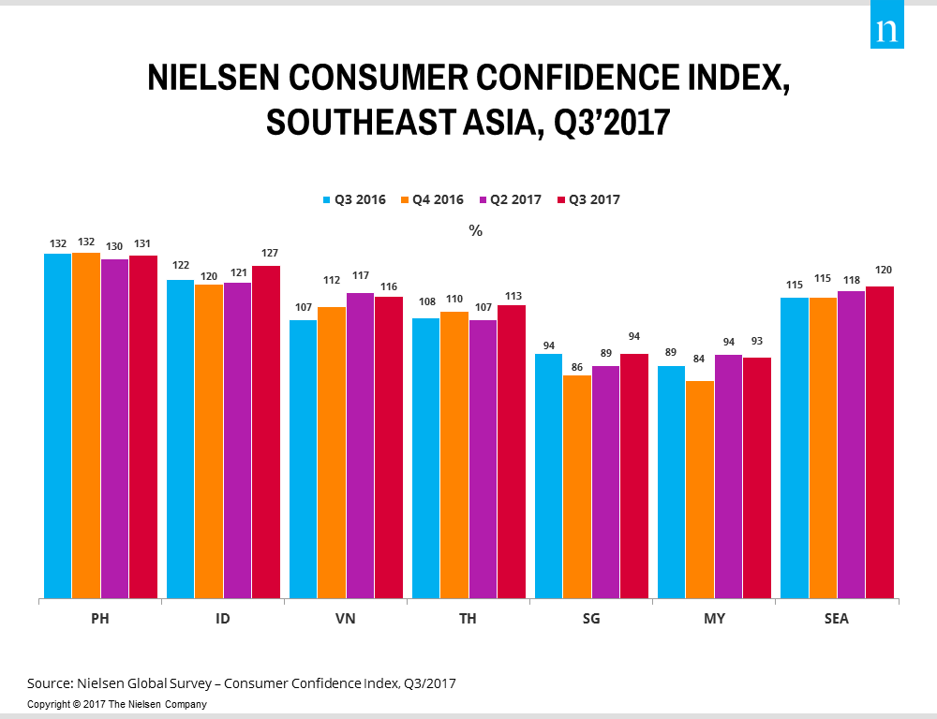

Chart 2: Spending and saving intentions of Vietnamese consumers, Q3/2017
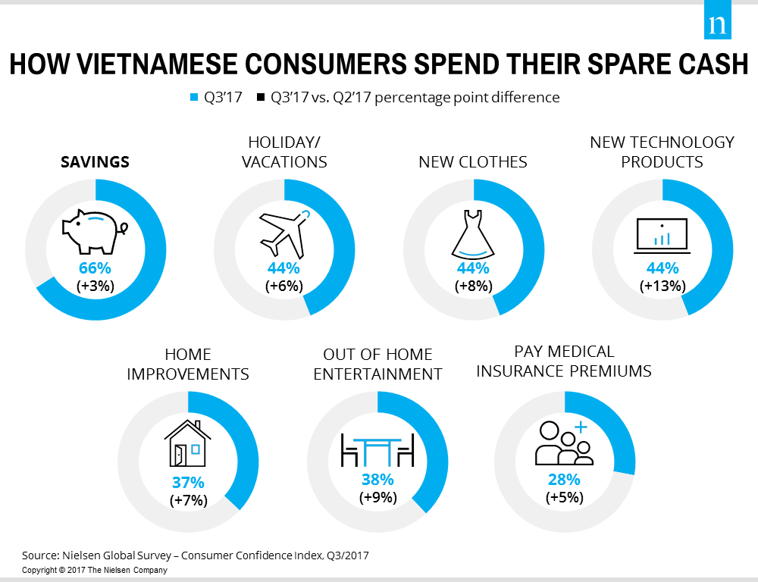

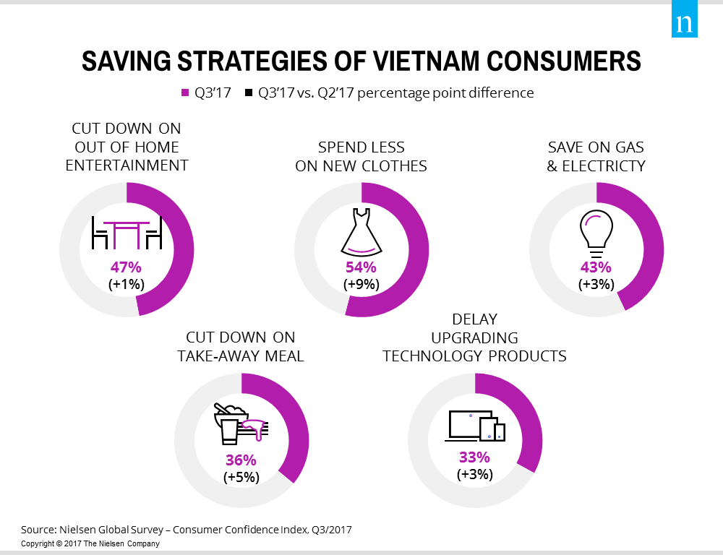

Chart 3: Major concerns of Vietnamese consumers – Q3/2017
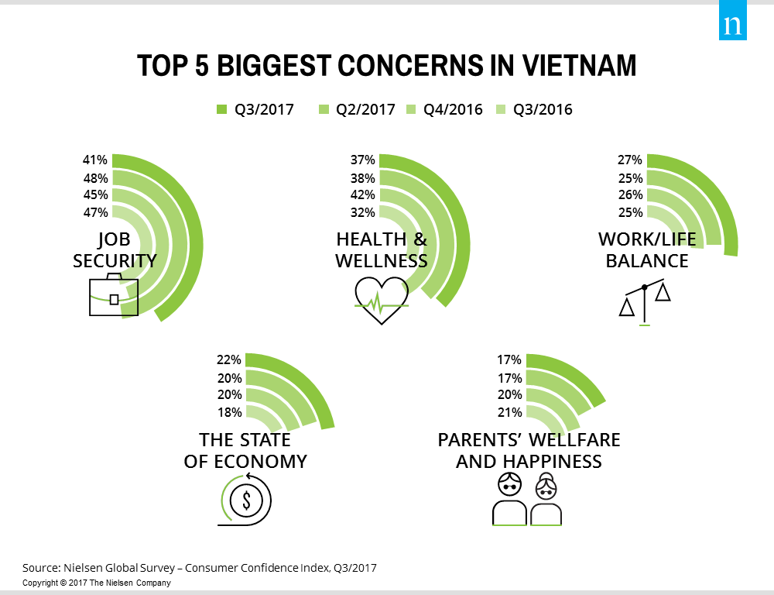

About Nielsen
Nielsen Holdings plc (NYSE: NLSN) is a global performance management company that provides a comprehensive understanding of what consumers Watch and Buy. Nielsen's Watch segment provides media and advertising clients with Total Audience measurement services across all devices where content — video, audio and text — is consumed. The Buy segment offers consumer packaged goods manufacturers and retailers the industry's only global view of retail performance measurement. By integrating information from its Watch and Buy segments and other data sources, Nielsen provides its clients with both world-class measurement as well as analytics that help improve performance. Nielsen, an S&P 500 company, has operations in over 100 countries that cover more than 90 percent of the world's population. For more information, visit www.nielsen.com.

