10/01/2018

SAVILLS REPORT ON Hanoi REAL ESTATE MARKET
Q4/2017
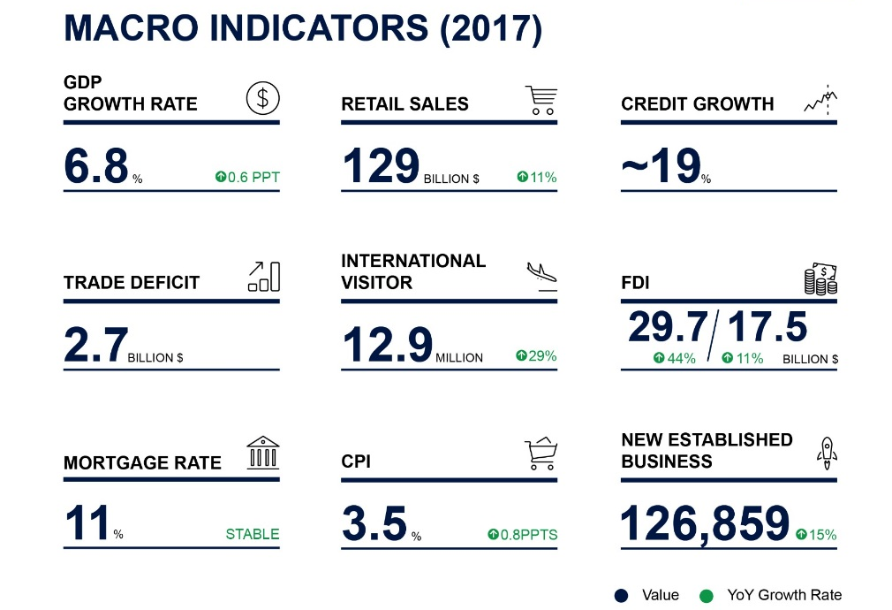
GDP grew at 6.8%, the highest in five years and exceeded the year target. GDP per capita of US$2,385 increased 10% year on year (YoY).

Credit growth is estimated to reach 18% to 19 percent. Estimated outstanding consumer borrowing increased 65% YoY. Loans for home buying and house repairs had a 53% share and increased 77% YoY.

Inbound tourism continued to grow in 2017 with12.9 million international visitors, up 29 percent. Accommodation and F&B revenues were approximately US$22million, up 12% YoY.

Total registered FDI growth was 44% and disbursement was up 11% over 2016. Japan, with an over 36% share led new FDI registered capital.

- RETAIL: Occupancy Increasing
Total stock was approximately 1.3 million m², up 1.2% quarter-on-quarter (QoQ) and 6.0% year on year (YoY). Nearly 19,000 m² was added from three new retail podiums.

Average ground floor rents decreased -2.0% QoQ. Occupancy maintained its upward trend with 2.6 ppts QoQ growth. The shopping centre segment and the Secondary area both saw the most improved QoQ and YoY occupancy rates.

Retail market performance
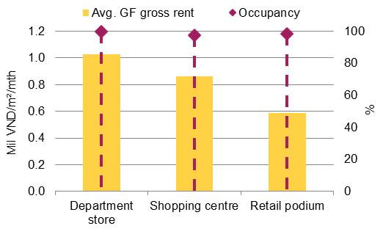
Thirteen new projects are scheduled to launch in 2018, cumulatively providing 229,000 m². The West area is seeing robust development of real estate projects and infrastructure.

- OFFICE: Improved Performance
Total stock was over 1.6 million m², up 1.6% QoQ but down -1.9% YoY after two new Grade B projects came online.

Average rents increased 1.4% QoQ and 2.6% YoY and average occupancy increased 1.1 ppts QoQ and 6.2 ppts YoY. Grade A had the most improved performance, particularly in non-CBD areas.
Office market performance
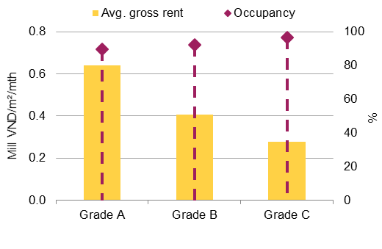
In 2017, newly registered businesses grew 11% YoY to 25,160. The new year will see fifteen new projects supplying nearly 299,000 m², mostly in the West. Increasing competition is expected from co-working space and officetel projects.

- SERVICED APARTMENT: Abundant New Supply
Fifty one mostly Grade A and B projects, launching 4,695 units saw stock up 14% QoQ and 17% YoY. From 2018, approximately 1,450 units will come online from twelve projects, with four more in development.

Service apartment market performance
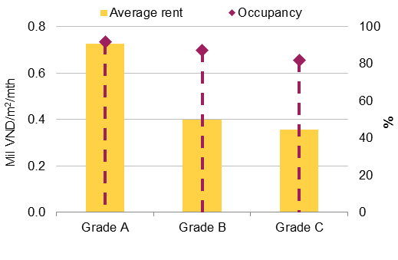
Average occupancy was 89%, down -0.6 ppts QoQ but up 1.7 ppts YoY. Average room rates (ARR) were VND540,000/m²/mth (US$23.7/m²/mth), down -4.5% QoQ and -4.6% YoY. New entries helped take-up achieve 400 units.
In 2017, registered FDI to Ha Noi was US$3.6 billion. Japan was the major source to Viet Nam in 2017 with US$9.11 billion.

- HOTEL: International Arrivals Record
One new hotel providing 151 rooms was officially graded 4-star. Stock was up to approximately 10,000 rooms, up 2% QoQ and 9% YoY.

The peak season saw average occupancy increase 6 ppts QoQ and overall 4 ppts YoY. ARR increased 3% QoQ and 17% YoY. RevPAR was up 12% QoQ and 24% YoY.

Hotel market performance
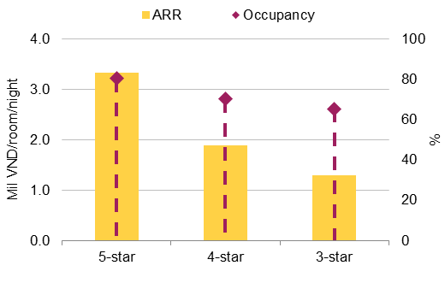
In 2017, Ha Noi had a new high of 4.95 million international visitors, a 23% YoY increase and approximately 40% of national arrivals.

With 42 Ha Noi projects coming online from 2018, pressure is set to increase across all Grades.

- APARTMENT: Grade A Beats Expectations
In Q4/2017, nineteen new and nineteen active projects added 7,010 units seeing stock up 14% QoQ but down 32% YoY. Primary supply was 25,260 units, up 6% QoQ and 17% YoY.

Absorption was 27%, up 3 ppts QoQ but down 4 ppts YoY. The average asking price was US$1,240/m², stable QoQ but down -12% YoY.
Apartment market performance
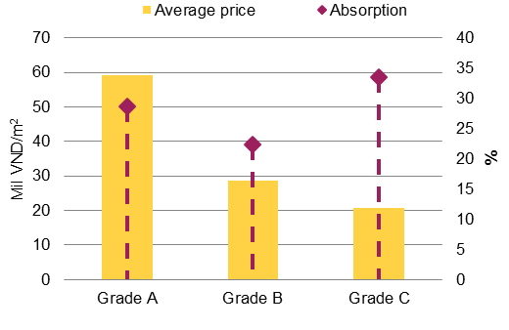
In 2017, 63 new projects entered. New launches remained unchanged YoY, but primary supply increased 14% YoY. Grade A had the best performance, tripling sales YoY.

In 2018, approximately 26,300 units will come online. Grade B is expected to continue leading supply.

- VILLA & TOWNHOUSE: Townhouses Doing Well
Total stock was 40,419 dwellings, increasing 3.3% QoQ and 15.3% YoY. Ha Dong District continues to lead with a 24% market share, followed by Hoai Duc.

Villa & townhouse stock
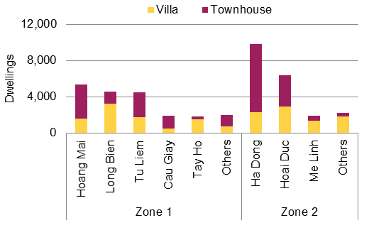
Ten new projects and three new phases supplied over 1,290 dwellings. Primary stock was approximately 3,924 dwellings, up 4% QoQ and 52% YoY.

Sales were up 23% QoQ and 83% YoY. Absorption was 36%, up 5.4 ppts QoQ and 6.1 ppts YoY. Townhouses accounted for 57% total sales.

From Q1/2018, new supply will be approximately 2,500 dwellings from 12 new projects. Key players are Vimedimex, Vingroup and Bitexco.
-End-

For any other enquiries, please contact:
Dinh Huong Linh (Ms.)  National Head of Marcom  Savills Vietnam  T:+84 24 3946 1300 Ext:112  F:+84 24 3946 1302  E:dhuonglinh@savills.com.vn | Nguyen Thi Kim Nga (Ms.)  PR Manager  Savills Ho Chi Minh City  T:+84 28 3823 9205 Ext:112  F:+84 28 3823 4571  E:NThiKimNga@savills.com.vn | Pham Thi Ha Phuong (Ms)  PR & Marketing Executive  Savills Hanoi  T:+84 24 3946 1300 Ext:120  F:+84 24 3946 1302  E:pthihaphuong@savills.com.vn |  | Pham Thi Ha Phuong (Ms)  PR & Marketing Executive  Savills Hanoi  T:+84 4 3946 1300 Ext:120  E:pthihaphuong@savills.com.vn

