News Release
Tran Le Thanh Van Nguyen Doan Phuoc Duy
Van.l.tran@nielsen.com duy.d.nguyen@nielsen.com

FMCG GROWTH GAINS MOMENTUM
IN THE THIRD QUARTER OF 2017,
HOWEVER THE MARKET STILL SHOWS VULNERABILITY

Vietnam 05 Dec, 2017 – The nationwide growth of FMCG in the third quarter of the year bounced back, after taking a dip in the previous quarter. This quarter, the nationwide FMCG reached 6.4% versus one year ago, mainly comes from an increase of 5.8% volume growth (see chart 1), according to the Nielsen Quarterly Market Pulse report released by Nielsen Vietnam - the global performance measurement company.
According to the report, when looking deeper into six super FMCG categories nationwide (beverage - including beer, food, milk base, household care, personal care and cigarettes), beverage enjoyed a big increase with the highest growth rate at 8.5%, led by an increase of 6.4% volume change. Cigarette also showed the positive growth in this quarter – 5.9%. On the other hand, other super categories didn’t show the same picture as these categories. Others all showed the stagnancy (see chart 2).

Market Pulse Report is based on the results of Nielsen Retail Measurement study of FMCG, on the major categories. The Nielsen Retail Measurement provides continuous tracking of product movement through defined retail outlets. The data are used to measure manufacturer and retailer effort as well as consumer off-take.

The report also shows that rural continue to be the highly potential land for many manufacturers. While urban has gained 4.7% growth this quarter compared to one year ago, rural has shown a stronger growth, up to 7.6%, mainly led by 7.4% volume growth and contributed 54% into the total FMCG sale. (See chart 3)
“On the heels of improving consumer confidence in the recent quarter, Vietnam’s GDP grew 6.9% in the first nine months of the year. This momentum was enhanced by consumers' optimistic perception of personal finance along with their willingness to spend. Despite the rise in GDP this year, Vietnam’s FMCG market has fluctuated over the past two years. The volatility which is reflected in super categories puts a lot of challenges for the manufacturers to make sound decisions to fully seize the market growth opportunities and drive a profitable business” - observed Nguyen Anh Dzung, Director, Retail Measurement Services, Nielsen Vietnam.

“Rural Vietnam, however, remains a high-potential opportunity for many manufacturers. And in rural, traditional trade channel, a complex and highly competitive channel, is still where most of the sales are taking place. Getting products to each and every retailer in rural to expand the distribution to drive more sales has long thought be to a challenging game for manufacturers. Therefore, stores segmentation or “where to focus” is what businesses are suggested to going after whenever thinking of expanding to this new potential market. As the rural Vietnamese community continues to evolve, transform and takes centre stage as a key group for businesses, understanding who they really are, where, how and what they are buying and their most effective touch points will be prerequisites for future success” – added Mr. Dzung.
Chart 1: FMCG growth
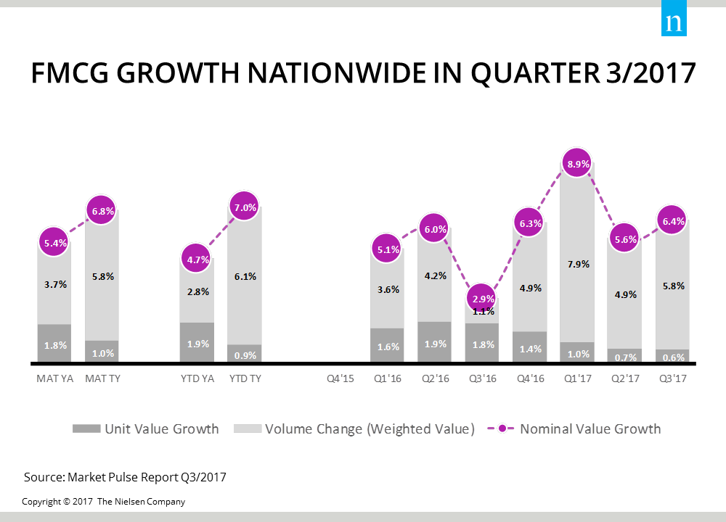
Chart 2: Super categories growth
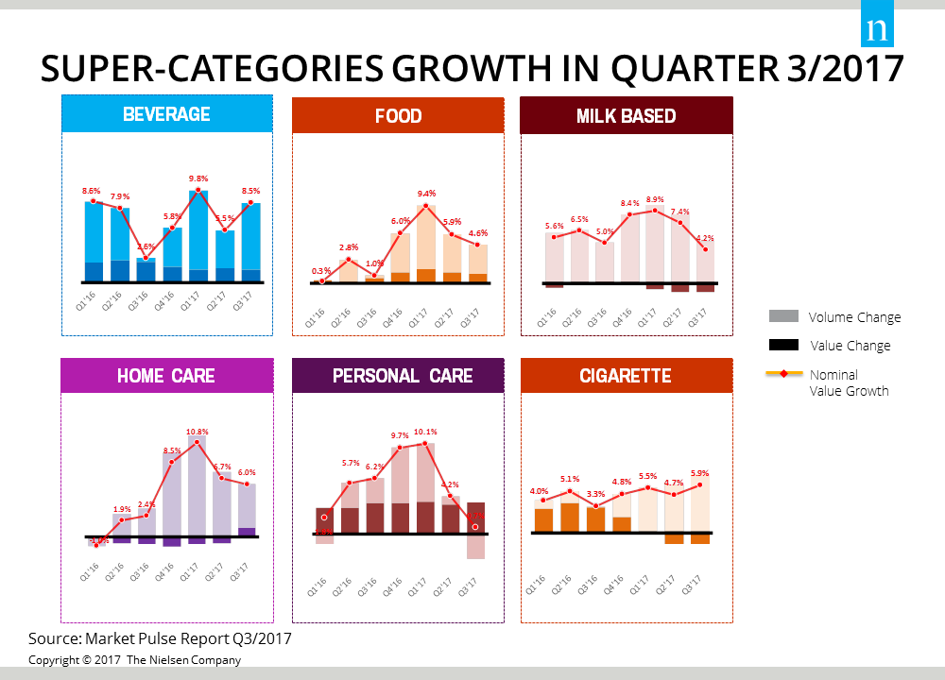

Chart 3: FMCG growth in urban vs. rural areas
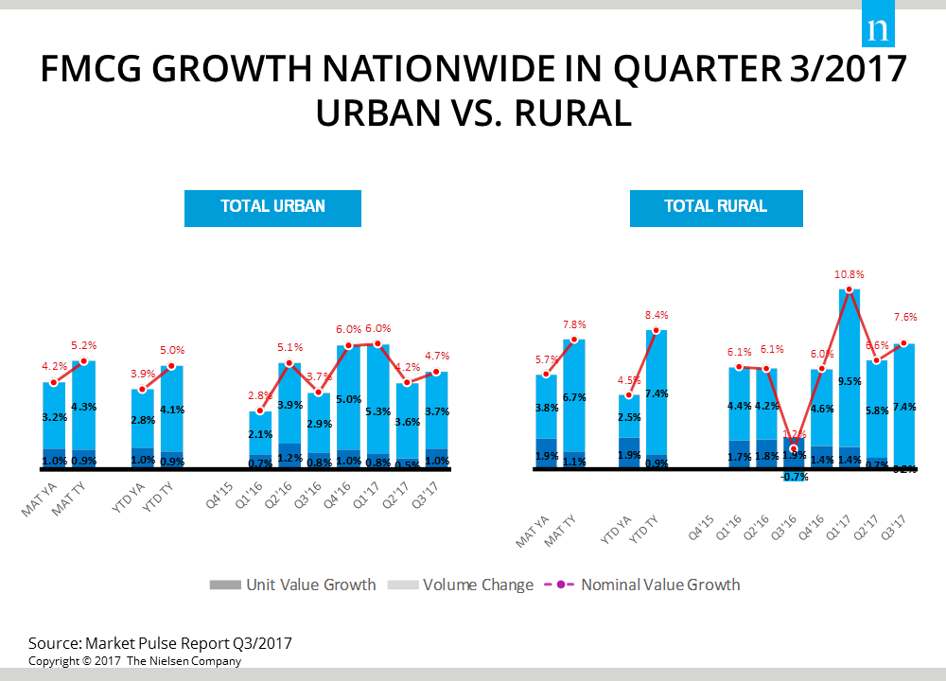

About Nielsen
Nielsen Holdings plc (NYSE: NLSN) is a global performance management company that provides a comprehensive understanding of what consumers Watch and Buy. Nielsen's Watch segment provides media and advertising clients with Total Audience measurement services across all devices where content — video, audio and text — is consumed. The Buy segment offers consumer packaged goods manufacturers and retailers the industry's only global view of retail performance measurement. By integrating information from its Watch and Buy segments and other data sources, Nielsen provides its clients with both world-class measurement as well as analytics that help improve performance. Nielsen, an S&P 500 company, has operations in over 100 countries that cover more than 90 percent of the world's population. For more information, visit www.nielsen.com.

Beverage includes: Beer, Soft Drink, Energy Drink, Sport Drink, Packaged Water, Tonic Food Drink, Fruit Juice, Tea Bag, Ready-To-Drink Tea, Ready To Drink Coffee, Coffee
Food includes: Biscuit, Pie and Sponge Cake, Snack, Cooking Oil, Instant Noodle, Chili Sauces, Gum, Meal Maker, Bouillon - MSG
Milk includes: Milk Powder, Spoon Yoghurt, Sweetened Condense Milk, Ready to drink milk
Household Care includes: Laundry, Dishwashing Liquid, Household Cleaner, Insecticide Aerosol, Insecticide Coil, Fabric Softener, Toilet Tissue
Personal Care includes: Facial Care Product, Shampoo, Hair Conditioner, Personal Wash, Toothpaste, Toothbrush, Facial Tissue, Feminine Protection, Mouth Wash, Deodorant, Body Lotion.

